Binary Search Tree :
In Binary Search Tree, all the left subtree elements should be less than root data and all the right subtree elements should be greater than or equal to root data. This is called binary search tree property.
This Property should be satisfied at every node in the tree.
Elementary Operations :
- Find Element
- Insertion
- Deletion
Question: Create Binary Search Tree for the following Sequence :
5, 16 , 22, 45, 2, 10, 18, 30, 50, 12, 1
Solution :

Example : Binary Search Tree
Values is : 13, 3, 4, 12, 14, 10, 5, 1, 8, 2, 7, 9, 11, 18
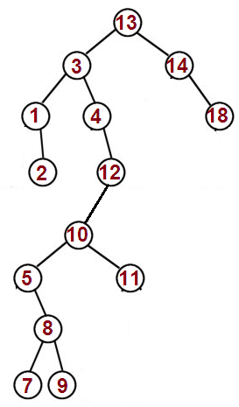

Question : Create Binary Search Tree for the following Sequence :
5,16,22,45,2,10,18,30,50,12,1
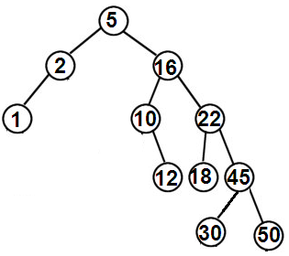

Example :
Create Binary Search Tree for the following Sequence :
Pink, Dolly, Gita, Sita, Hari, Alka, Tina
Solution :
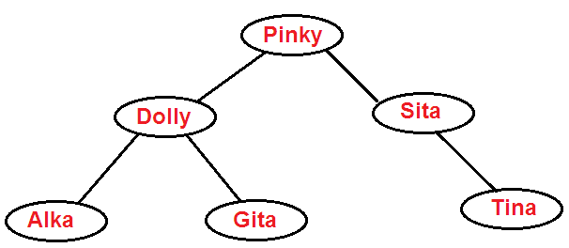
Note: In Binary Search Tree, the Left Node <Parent Node <= Right Node

